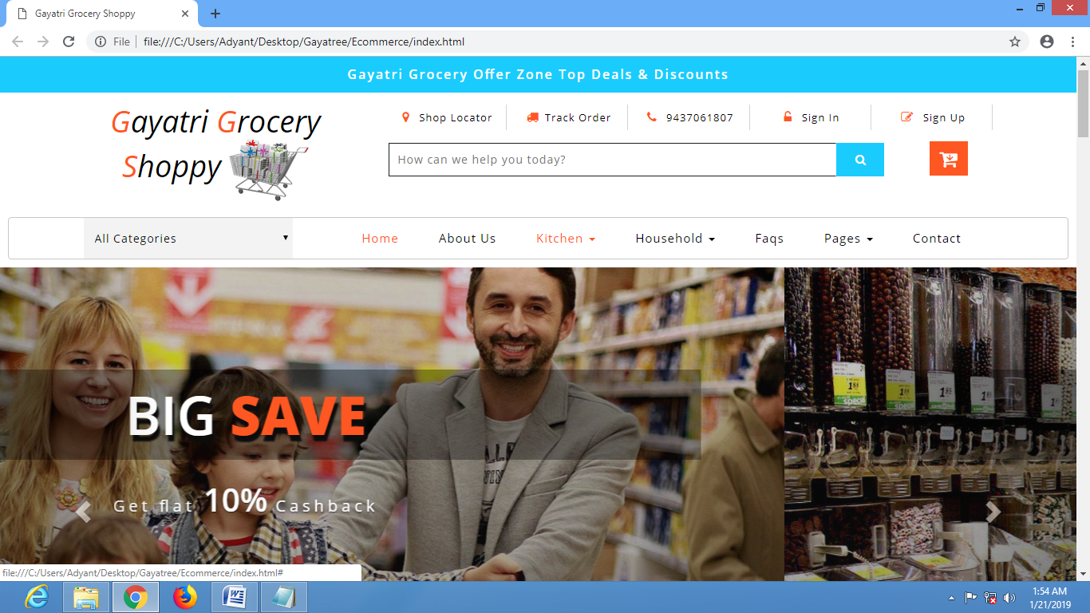

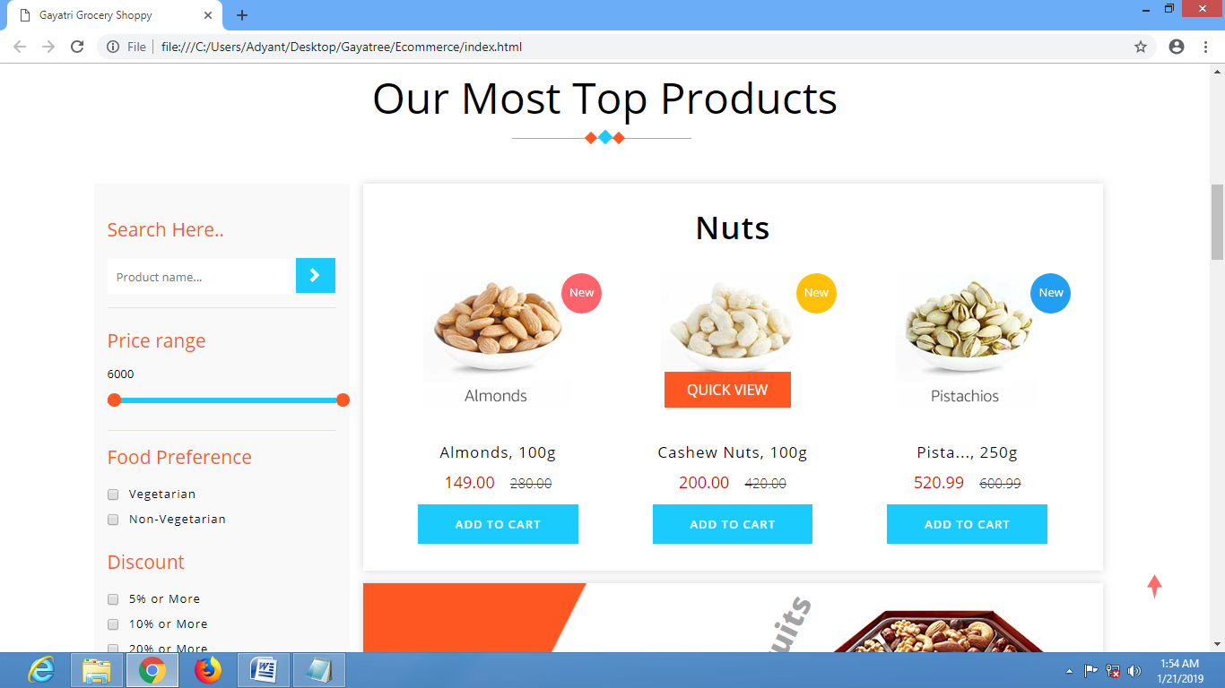

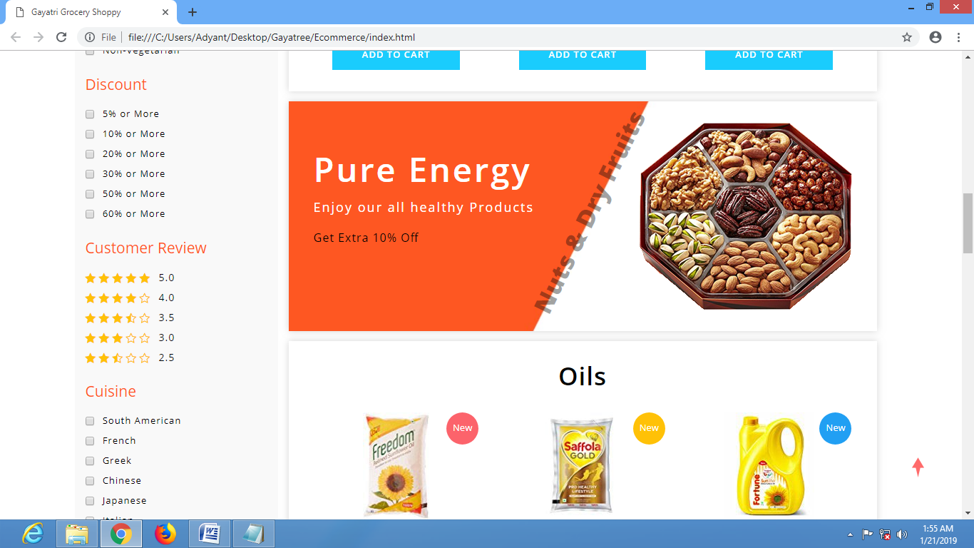

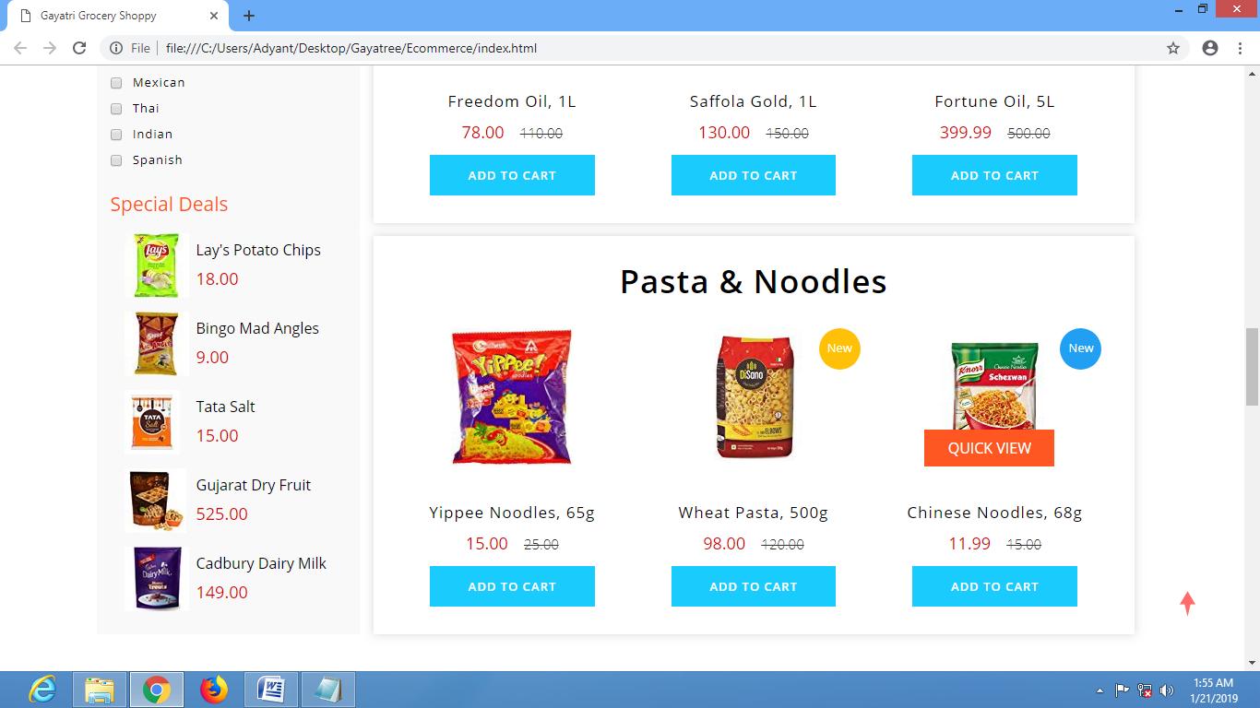

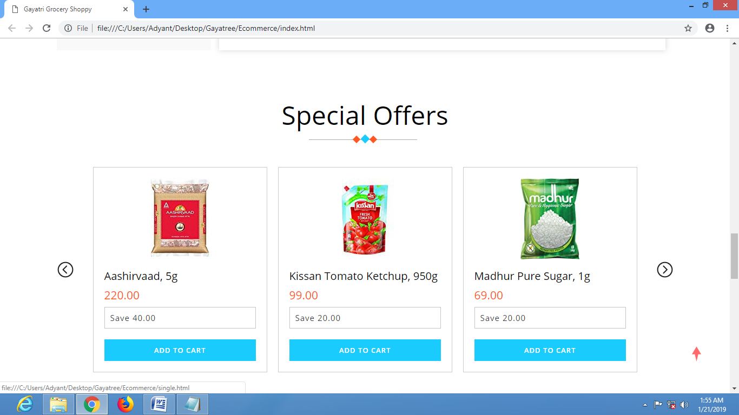

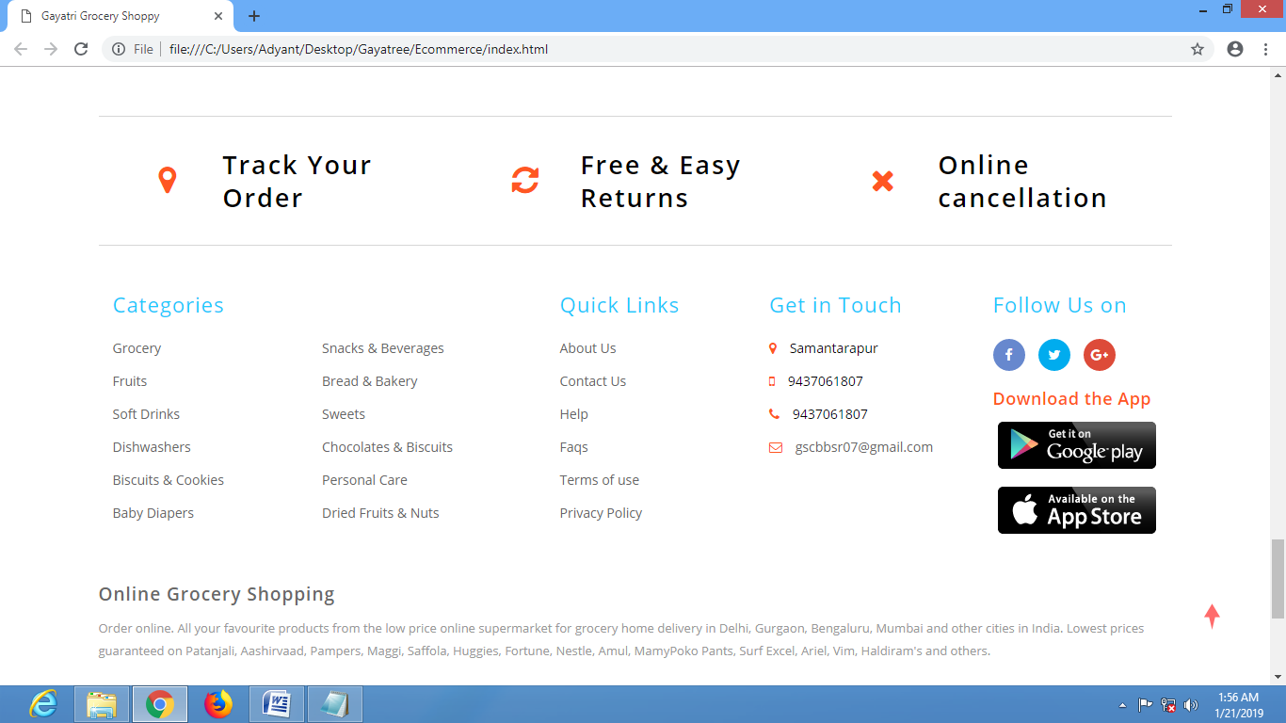

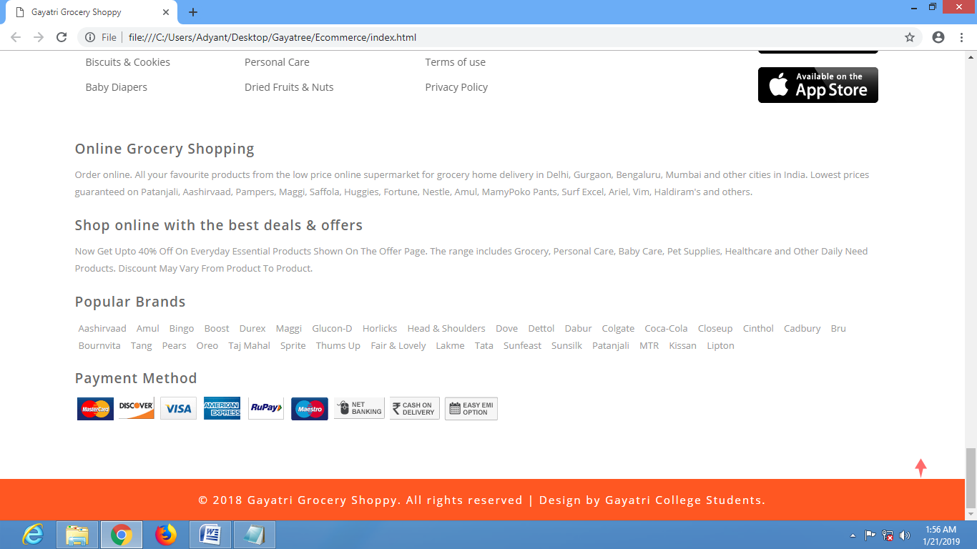

HTML CODE

<!DOCTYPE html>

<html >

<head>

<title>Gayatri Grocery Shoppy </title>

</head>

<body>

<!-- top-header -->

<div class="header-most-top">

<p>Gayatri Grocery Offer Zone Top Deals & Discounts</p>

</div>

<!-- //top-header -->

<!-- header-bot-->

<div class="header-bot">

<div class="header-bot_inner_wthreeinfo_header_mid">

<!-- header-bot-->

<div class="col-md-4 logo_agile">

<h1>

<a href="index.html">

<span>G</span>ayatri

<span>G</span>rocery

<span>S</span>hoppy

<img src="images/logo2.png" alt=" ">

</a>

</h1>

</div>

<!-- header-bot -->

<div class="col-md-8 header">

<!-- header lists -->

<ul>

<li>

<a class="play-icon popup-with-zoom-anim" href="#small-dialog1">

<span class="fa fa-map-marker" aria-hidden="true"></span> Shop Locator</a>

</li>

<li>

<a href="#" data-toggle="modal" data-target="#myModal1">

<span class="fa fa-truck" aria-hidden="true"></span>Track Order</a>

</li>

<li>

<span class="fa fa-phone" aria-hidden="true"></span>

</li>

<li>

<a href="#" data-toggle="modal" data-target="#myModal1">

<span class="fa fa-unlock-alt" aria-hidden="true"></span> Sign In </a>

</li>

<li>

<a href="#" data-toggle="modal" data-target="#myModal2">

<span class="fa fa-pencil-square-o" aria-hidden="true"></span> Sign Up </a>

</li>

</ul>

<!-- //header lists -->

<!-- search -->

<div class="agileits_search">

<form action="#" method="post">

<input name="Search" type="search" placeholder="How can we help you today?" required="">

<button type="submit" class="btn btn-default" aria-label="Left Align">

<span class="fa fa-search" aria-hidden="true"> </span>

</button>

</form>

</div>

<!-- //search -->

<!-- cart details -->

<div class="top_nav_right">

<div class="wthreecartaits wthreecartaits2 cart cart box_1">

<form action="#" method="post" class="last">

<input type="hidden" name="cmd" value="_cart">

<input type="hidden" name="display" value="1">

<button class="w3view-cart" type="submit" name="submit" value="">

<i class="fa fa-cart-arrow-down" aria-hidden="true"></i>

</button>

</form>

</div>

</div>

<!-- //cart details -->

<div class="clearfix"></div>

</div>

<div class="clearfix"></div>

</div>

</div>

<!-- shop locator (popup) -->

<!-- Button trigger modal(shop-locator) -->

<div id="small-dialog1" class="mfp-hide">

<div class="select-city">

<h3>Please Select Your Location</h3>

<select class="list_of_cities">

<optgroup label="Popular Cities">

<option selected style="display:none;color:#eee;">Select City</option>

<option>Birmingham</option>

<option>Anchorage</option>

<option>Phoenix</option>

<option>Little Rock</option>

<option>Los Angeles</option>

<option>Denver</option>

<option>Bridgeport</option>

<option>Wilmington</option>

<option>Jacksonville</option>

<option>Atlanta</option>

<option>Honolulu</option>

<option>Boise</option>

<option>Chicago</option>

<option>Indianapolis</option>

</optgroup>

<optgroup label="Alabama">

<option>Birmingham</option>

<option>Montgomery</option>

<option>Mobile</option>

<option>Huntsville</option>

<option>Tuscaloosa</option>

</optgroup>

<optgroup label="Alaska">

<option>Anchorage</option>

<option>Fairbanks</option>

<option>Juneau</option>

<option>Sitka</option>

<option>Ketchikan</option>

</optgroup>

<optgroup label="Arizona">

<option>Phoenix</option>

<option>Tucson</option>

<option>Mesa</option>

<option>Chandler</option>

<option>Glendale</option>

</optgroup>

<optgroup label="Arkansas">

<option>Little Rock</option>

<option>Fort Smith</option>

<option>Fayetteville</option>

<option>Springdale</option>

<option>Jonesboro</option>

</optgroup>

<optgroup label="California">

<option>Los Angeles</option>

<option>San Diego</option>

<option>San Jose</option>

<option>San Francisco</option>

<option>Fresno</option>

</optgroup>

<optgroup label="Colorado">

<option>Denver</option>

<option>Colorado</option>

<option>Aurora</option>

<option>Fort Collins</option>

<option>Lakewood</option>

</optgroup>

<optgroup label="Connecticut">

<option>Bridgeport</option>

<option>New Haven</option>

<option>Hartford</option>

<option>Stamford</option>

<option>Waterbury</option>

</optgroup>

<optgroup label="Delaware">

<option>Wilmington</option>

<option>Dover</option>

<option>Newark</option>

<option>Bear</option>

<option>Middletown</option>

</optgroup>

<optgroup label="Florida">

<option>Jacksonville</option>

<option>Miami</option>

<option>Tampa</option>

<option>St. Petersburg</option>

<option>Orlando</option>

</optgroup>

<optgroup label="Georgia">

<option>Atlanta</option>

<option>Augusta</option>

<option>Columbus</option>

<option>Savannah</option>

<option>Athens</option>

</optgroup>

<optgroup label="Hawaii">

<option>Honolulu</option>

<option>Pearl City</option>

<option>Hilo</option>

<option>Kailua</option>

<option>Waipahu</option>

</optgroup>

<optgroup label="Idaho">

<option>Boise</option>

<option>Nampa</option>

<option>Meridian</option>

<option>Idaho Falls</option>

<option>Pocatello</option>

</optgroup>

<optgroup label="Illinois">

<option>Chicago</option>

<option>Aurora</option>

<option>Rockford</option>

<option>Joliet</option>

<option>Naperville</option>

</optgroup>

<optgroup label="Indiana">

<option>Indianapolis</option>

<option>Fort Wayne</option>

<option>Evansville</option>

<option>South Bend</option>

<option>Hammond</option>

</optgroup>

<optgroup label="Iowa">

<option>Des Moines</option>

<option>Cedar Rapids</option>

<option>Davenport</option>

<option>Sioux City</option>

<option>Waterloo</option>

</optgroup>

<optgroup label="Kansas">

<option>Wichita</option>

<option>Overland Park</option>

<option>Kansas City</option>

<option>Topeka</option>

<option>Olathe </option>

</optgroup>

<optgroup label="Kentucky">

<option>Louisville</option>

<option>Lexington</option>

<option>Bowling Green</option>

<option>Owensboro</option>

<option>Covington</option>

</optgroup>

<optgroup label="Louisiana">

<option>New Orleans</option>

<option>Baton Rouge</option>

<option>Shreveport</option>

<option>Metairie</option>

<option>Lafayette</option>

</optgroup>

<optgroup label="Maine">

<option>Portland</option>

<option>Lewiston</option>

<option>Bangor</option>

<option>South Portland</option>

<option>Auburn</option>

</optgroup>

<optgroup label="Maryland">

<option>Baltimore</option>

<option>Frederick</option>

<option>Rockville</option>

<option>Gaithersburg</option>

<option>Bowie</option>

</optgroup>

<optgroup label="Massachusetts">

<option>Boston</option>

<option>Worcester</option>

<option>Springfield</option>

<option>Lowell</option>

<option>Cambridge</option>

</optgroup>

<optgroup label="Michigan">

<option>Detroit</option>

<option>Grand Rapids</option>

<option>Warren</option>

<option>Sterling Heights</option>

<option>Lansing</option>

</optgroup>

<optgroup label="Minnesota">

<option>Minneapolis</option>

<option>St. Paul</option>

<option>Rochester</option>

<option>Duluth</option>

<option>Bloomington</option>

</optgroup>

<optgroup label="Mississippi">

<option>Jackson</option>

<option>Gulfport</option>

<option>Southaven</option>

<option>Hattiesburg</option>

<option>Biloxi</option>

</optgroup>

<optgroup label="Missouri">

<option>Kansas City</option>

<option>St. Louis</option>

<option>Springfield</option>

<option>Independence</option>

<option>Columbia</option>

</optgroup>

<optgroup label="Montana">

<option>Billings</option>

<option>Missoula</option>

<option>Great Falls</option>

<option>Bozeman</option>

<option>Butte-Silver Bow</option>

</optgroup>

<optgroup label="Nebraska">

<option>Omaha</option>

<option>Lincoln</option>

<option>Bellevue</option>

<option>Grand Island</option>

<option>Kearney</option>

</optgroup>

<optgroup label="Nevada">

<option>Las Vegas</option>

<option>Henderson</option>

<option>North Las Vegas</option>

<option>Reno</option>

<option>Sunrise Manor</option>

</optgroup>

<optgroup label="New Hampshire">

<option>Manchesters</option>

<option>Nashua</option>

<option>Concord</option>

<option>Dover</option>

<option>Rochester</option>

</optgroup>

<optgroup label="New Jersey">

<option>Newark</option>

<option>Jersey City</option>

<option>Paterson</option>

<option>Elizabeth</option>

<option>Edison</option>

</optgroup>

<optgroup label="New Mexico">

<option>Albuquerque</option>

<option>Las Cruces</option>

<option>Rio Rancho</option>

<option>Santa Fe</option>

<option>Roswell</option>

</optgroup>

<optgroup label="New York">

<option>New York</option>

<option>Buffalo</option>

<option>Rochester</option>

<option>Yonkers</option>

<option>Syracuse</option>

</optgroup>

<optgroup label="North Carolina">

<option>Charlotte</option>

<option>Raleigh</option>

<option>Greensboro</option>

<option>Winston-Salem</option>

<option>Durham</option>

</optgroup>

<optgroup label="North Dakota">

<option>Fargo</option>

<option>Bismarck</option>

<option>Grand Forks</option>

<option>Minot</option>

<option>West Fargo</option>

</optgroup>

<optgroup label="Ohio">

<option>Columbus</option>

<option>Cleveland</option>

<option>Cincinnati</option>

<option>Toledo</option>

<option>Akron</option>

</optgroup>

<optgroup label="Oklahoma">

<option>Oklahoma City</option>

<option>Tulsa</option>

<option>Norman</option>

<option>Broken Arrow</option>

<option>Lawton</option>

</optgroup>

<optgroup label="Oregon">

<option>Portland</option>

<option>Eugene</option>

<option>Salem</option>

<option>Gresham</option>

<option>Hillsboro</option>

</optgroup>

<optgroup label="Pennsylvania">

<option>Philadelphia</option>

<option>Pittsburgh</option>

<option>Allentown</option>

<option>Erie</option>

<option>Reading</option>

</optgroup>

<optgroup label="Rhode Island">

<option>Providence</option>

<option>Warwick</option>

<option>Cranston</option>

<option>Pawtucket</option>

<option>East Providence</option>

</optgroup>

<optgroup label="South Carolina">

<option>Columbia</option>

<option>Charleston</option>

<option>North Charleston</option>

<option>Mount Pleasant</option>

<option>Rock Hill</option>

</optgroup>

<optgroup label="South Dakota">

<option>Sioux Falls</option>

<option>Rapid City</option>

<option>Aberdeen</option>

<option>Brookings</option>

<option>Watertown</option>

</optgroup>

<optgroup label="Tennessee">

<option>Memphis</option>

<option>Nashville</option>

<option>Knoxville</option>

<option>Chattanooga</option>

<option>Clarksville</option>

</optgroup>

<optgroup label="Texas">

<option>Houston</option>

<option>San Antonio</option>

<option>Dallas</option>

<option>Austin</option>

<option>Fort Worth</option>

</optgroup>

<optgroup label="Utah">

<option>Salt Lake City</option>

<option>West Valley City</option>

<option>Provo</option>

<option>West Jordan</option>

<option>Orem</option>

</optgroup>

<optgroup label="Vermont">

<option>Burlington</option>

<option>Essex</option>

<option>South Burlington</option>

<option>Colchester</option>

<option>Rutland</option>

</optgroup>

<optgroup label="Virginia">

<option>Virginia Beach</option>

<option>Norfolk</option>

<option>Chesapeake</option>

<option>Arlington</option>

<option>Richmond</option>

</optgroup>

<optgroup label="Washington">

<option>Seattle</option>

<option>Spokane</option>

<option>Tacoma</option>

<option>Vancouver</option>

<option>Bellevue</option>

</optgroup>

<optgroup label="West Virginia">

<option>Charleston</option>

<option>Huntington</option>

<option>Parkersburg</option>

<option>Morgantown</option>

<option>Wheeling</option>

</optgroup>

<optgroup label="Wisconsin">

<option>Milwaukee</option>

<option>Madison</option>

<option>Green Bay</option>

<option>Kenosha</option>

<option>Racine</option>

</optgroup>

<optgroup label="Wyoming">

<option>Cheyenne</option>

<option>Casper</option>

<option>Laramie</option>

<option>Gillette</option>

<option>Rock Springs</option>

</optgroup>

</select>

<div class="clearfix"></div>

</div>

</div>

<!-- //shop locator (popup) -->

<!-- signin Model -->

<!-- Modal1 -->

<div class="modal fade" id="myModal1" tabindex="-1" role="dialog">

<div class="modal-dialog">

<!-- Modal content-->

<div class="modal-content">

<div class="modal-header">

<button type="button" class="close" data-dismiss="modal">&times;</button>

</div>

<div class="modal-body modal-body-sub_agile">

<div class="main-mailposi">

<span class="fa fa-envelope-o" aria-hidden="true"></span>

</div>

<div class="modal_body_left modal_body_left1">

<h3 class="agileinfo_sign">Sign In </h3>

<p>

Sign In now, Let's start your Grocery Shopping. Don't have an account?

<a href="#" data-toggle="modal" data-target="#myModal2">

Sign Up Now</a>

</p>

<form action="#" method="post">

<div class="styled-input agile-styled-input-top">

<input type="text" placeholder="User Name" name="Name" required="">

</div>

<div class="styled-input">

<input type="password" placeholder="Password" name="password" required="">

</div>

<input type="submit" value="Sign In">

</form>

<div class="clearfix"></div>

</div>

<div class="clearfix"></div>

</div>

</div>

<!-- //Modal content-->

</div>

</div>

<!-- //Modal1 -->

<!-- //signin Model -->

<!-- signup Model -->

<!-- Modal2 -->

<div class="modal fade" id="myModal2" tabindex="-1" role="dialog">

<div class="modal-dialog">

<!-- Modal content-->

<div class="modal-content">

<div class="modal-header">

<button type="button" class="close" data-dismiss="modal">&times;</button>

</div>

<div class="modal-body modal-body-sub_agile">

<div class="main-mailposi">

<span class="fa fa-envelope-o" aria-hidden="true"></span>

</div>

<div class="modal_body_left modal_body_left1">

<h3 class="agileinfo_sign">Sign Up</h3>

<p>

Come join the Grocery Shoppy! Let's set up your Account.

</p>

<form action="#" method="post">

<div class="styled-input agile-styled-input-top">

<input type="text" placeholder="Name" name="Name" required="">

</div>

<div class="styled-input">

<input type="email" placeholder="E-mail" name="Email" required="">

</div>

<div class="styled-input">

<input type="password" placeholder="Password" name="password" id="password1" required="">

</div>

<div class="styled-input">

<input type="password" placeholder="Confirm Password" name="Confirm Password" id="password2" required="">

</div>

<input type="submit" value="Sign Up">

</form>

<p>

<a href="#">By clicking register, I agree to your terms</a>

</p>

</div>

</div>

</div>

<!-- //Modal content-->

</div>

</div>

<!-- //Modal2 -->

<!-- //signup Model -->

<!-- //header-bot -->

<!-- navigation -->

<div class="ban-top">

<div class="container">

<div class="agileits-navi_search">

<form action="#" method="post">

<select id="agileinfo-nav_search" name="agileinfo_search" required="">

<option value="">All Categories</option>

<option value="Kitchen">Kitchen</option>

<option value="Household">Household</option>

<option value="Snacks &amp; Beverages">Snacks & Beverages</option>

<option value="Personal Care">Personal Care</option>

<option value="Gift Hampers">Gift Hampers</option>

<option value="Fruits &amp; Vegetables">Fruits & Vegetables</option>

<option value="Baby Care">Baby Care</option>

<option value="Soft Drinks &amp; Juices">Soft Drinks & Juices</option>

<option value="Frozen Food">Frozen Food</option>

<option value="Bread &amp; Bakery">Bread & Bakery</option>

<option value="Sweets">Sweets</option>

</select>

</form>

</div>

<div class="top_nav_left">

<nav class="navbar navbar-default">

<div class="container-fluid">

<!-- Brand and toggle get grouped for better mobile display -->

<div class="navbar-header">

<button type="button" class="navbar-toggle collapsed" data-toggle="collapse" data-target="#bs-example-navbar-collapse-1"

aria-expanded="false">

<span class="sr-only">Toggle navigation</span>

<span class="icon-bar"></span>

<span class="icon-bar"></span>

<span class="icon-bar"></span>

</button>

</div>

<!-- Collect the nav links, forms, and other content for toggling -->

<div class="collapse navbar-collapse menu--shylock" id="bs-example-navbar-collapse-1">

<ul class="nav navbar-nav menu__list">

<li class="active">

<a class="nav-stylehead" href="index.html">Home

<span class="sr-only">(current)</span>

</a>

</li>

<li class="">

<a class="nav-stylehead" href="about.html">About Us</a>

</li>

<li class="dropdown">

<a href="#" class="dropdown-toggle nav-stylehead" data-toggle="dropdown" role="button" aria-haspopup="true" aria-expanded="false">Kitchen

<span class="caret"></span>

</a>

<ul class="dropdown-menu multi-column columns-3">

<div class="agile_inner_drop_nav_info">

<div class="col-sm-4 multi-gd-img">

<ul class="multi-column-dropdown">

<li>

<a href="product.html">Bakery</a>

</li>

<li>

<a href="product.html">Baking Supplies</a>

</li>

<li>

<a href="product.html">Coffee, Tea & Beverages</a>

</li>

<li>

<a href="product.html">Dried Fruits, Nuts</a>

</li>

<li>

<a href="product.html">Sweets, Chocolate</a>

</li>

<li>

<a href="product.html">Spices & Masalas</a>

</li>

<li>

<a href="product.html">Jams, Honey & Spreads</a>

</li>

</ul>

</div>

<div class="col-sm-4 multi-gd-img">

<ul class="multi-column-dropdown">

<li>

<a href="product.html">Pickles</a>

</li>

<li>

<a href="product.html">Pasta & Noodles</a>

</li>

<li>

<a href="product.html">Rice, Flour & Pulses</a>

</li>

<li>

<a href="product.html">Sauces & Cooking Pastes</a>

</li>

<li>

<a href="product.html">Snack Foods</a>

</li>

<li>

<a href="product.html">Oils, Vinegars</a>

</li>

<li>

<a href="product.html">Meat, Poultry & Seafood</a>

</li>

</ul>

</div>

<div class="col-sm-4 multi-gd-img">

<img src="images/nav.png" alt="">

</div>

<div class="clearfix"></div>

</div>

</ul>

</li>

<li class="dropdown">

<a href="#" class="dropdown-toggle nav-stylehead" data-toggle="dropdown" role="button" aria-haspopup="true" aria-expanded="false">Household

<span class="caret"></span>

</a>

<ul class="dropdown-menu multi-column columns-3">

<div class="agile_inner_drop_nav_info">

<div class="col-sm-6 multi-gd-img">

<ul class="multi-column-dropdown">

<li>

<a href="product2.html">Kitchen & Dining</a>

</li>

<li>

<a href="product2.html">Detergents</a>

</li>

<li>

<a href="product2.html">Utensil Cleaners</a>

</li>

<li>

<a href="product2.html">Floor & Other Cleaners</a>

</li>

<li>

<a href="product2.html">Disposables, Garbage Bag</a>

</li>

<li>

<a href="product2.html">Repellents & Fresheners</a>

</li>

<li>

<a href="product2.html"> Dishwash</a>

</li>

</ul>

</div>

<div class="col-sm-6 multi-gd-img">

<ul class="multi-column-dropdown">

<li>

<a href="product2.html">Pet Care</a>

</li>

<li>

<a href="product2.html">Cleaning Accessories</a>

</li>

<li>

<a href="product2.html">Pooja Needs</a>

</li>

<li>

<a href="product2.html">Crackers</a>

</li>

<li>

<a href="product2.html">Festive Decoratives</a>

</li>

<li>

<a href="product2.html">Plasticware</a>

</li>

<li>

<a href="product2.html">Home Care</a>

</li>

</ul>

</div>

<div class="clearfix"></div>

</div>

</ul>

</li>

<li class="">

<a class="nav-stylehead" href="faqs.html">Faqs</a>

</li>

<li class="dropdown">

<a class="nav-stylehead dropdown-toggle" href="#" data-toggle="dropdown">Pages

<b class="caret"></b>

</a>

<ul class="dropdown-menu agile_short_dropdown">

<li>

<a href="icons.html">Web Icons</a>

</li>

<li>

<a href="typography.html">Typography</a>

</li>

</ul>

</li>

<li class="">

<a class="nav-stylehead" href="contact.html">Contact</a>

</li>

</ul>

</div>

</div>

</nav>

</div>

</div>

</div>

<!-- //navigation -->

<!-- banner -->

<div id="myCarousel" class="carousel slide" data-ride="carousel">

<!-- Indicators-->

<ol class="carousel-indicators">

<li data-target="#myCarousel" data-slide-to="0" class="active"></li>

<li data-target="#myCarousel" data-slide-to="1" class=""></li>

<li data-target="#myCarousel" data-slide-to="2" class=""></li>

<li data-target="#myCarousel" data-slide-to="3" class=""></li>

</ol>

<div class="carousel-inner" role="listbox">

<div class="item active">

<div class="container">

<div class="carousel-caption">

<h3>Big

<span>Save</span>

</h3>

<p>Get flat

<span>10%</span> Cashback</p>

<a class="button2" href="product.html">Shop Now </a>

</div>

</div>

</div>

<div class="item item2">

<div class="container">

<div class="carousel-caption">

<h3>Healthy

<span>Saving</span>

</h3>

<p>Get Upto

<span>30%</span> Off</p>

<a class="button2" href="product.html">Shop Now </a>

</div>

</div>

</div>

<div class="item item3">

<div class="container">

<div class="carousel-caption">

<h3>Big

<span>Deal</span>

</h3>

<p>Get Best Offer Upto

<span>20%</span>

</p>

<a class="button2" href="product.html">Shop Now </a>

</div>

</div>

</div>

<div class="item item4">

<div class="container">

<div class="carousel-caption">

<h3>Today

<span>Discount</span>

</h3>

<p>Get Now

<span>40%</span> Discount</p>

<a class="button2" href="product.html">Shop Now </a>

</div>

</div>

</div>

</div>

<a class="left carousel-control" href="#myCarousel" role="button" data-slide="prev">

<span class="glyphicon glyphicon-chevron-left" aria-hidden="true"></span>

<span class="sr-only">Previous</span>

</a>

<a class="right carousel-control" href="#myCarousel" role="button" data-slide="next">

<span class="glyphicon glyphicon-chevron-right" aria-hidden="true"></span>

<span class="sr-only">Next</span>

</a>

</div>

<!-- //banner -->

<!---728x90--->

<!-- top Products -->

<div class="ads-grid">

<div class="container">

<!-- tittle heading -->

<h3 class="tittle-w3l">AboutUs

<span class="heading-style">

<i></i>

<i></i>

<i></i>

</span>

</h3>

</div>

</div>

<div class="copy-right">

<div class="container">

<!----------------------------//Footer Details------------------------------->

<p>© 2018 Gayatri Grocery Shoppy. All rights reserved | Design by

Gayatri College Students.

</p>

</div>

</div>

<!-- //copyright -->